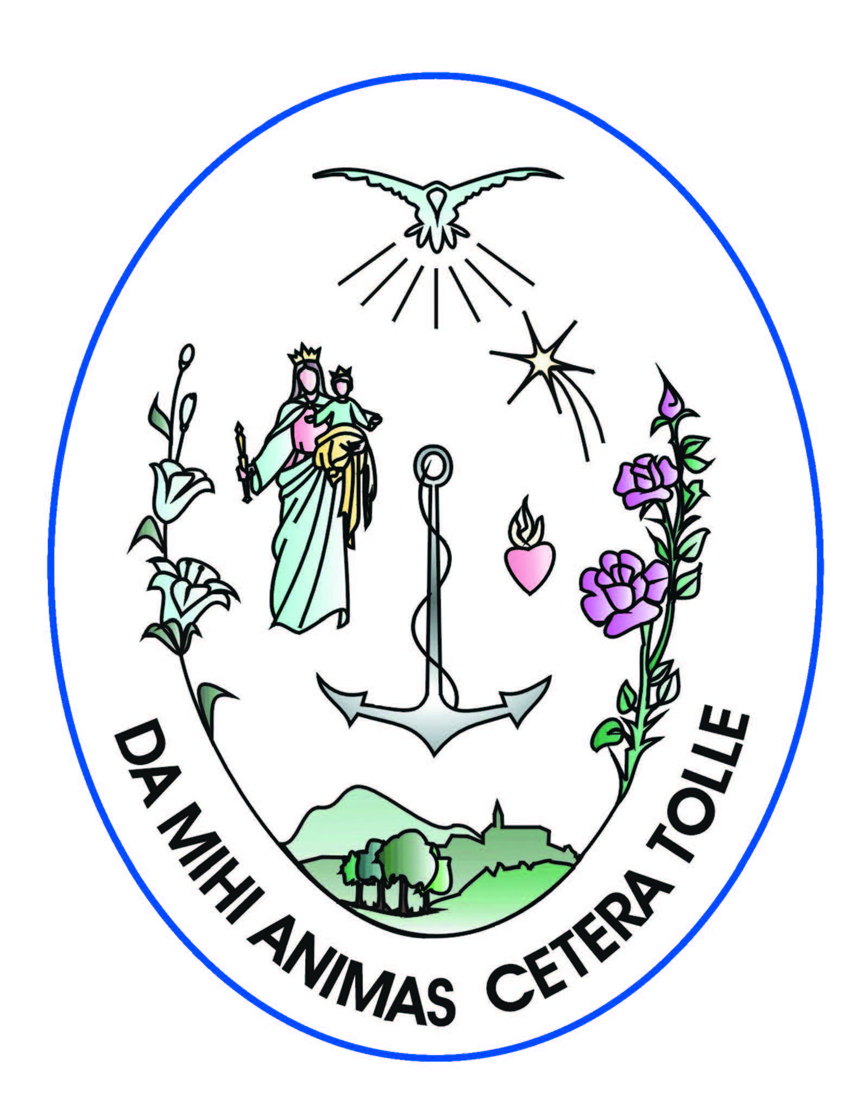
INSTITUTE OF THE DAUGHTERS OF MARY HELP OF CHRISTIANS
Via Ateneo Salesiano, 81 – 00139 Rome

The Superior General

Greeting from the Superior General of the FMA,
Mother Yvonne Reungoat fma,
to GC27

With all my heart, and in the name of our General Council and all the Daughters of Mary Help of Christians around the world, I greet the Bishops and Cardinals who are gathered here and the representatives of other Groups of the Salesian Family. With particular affection and gratitude I greet the Centre of unity for this Family, the Rector Major, Fr Pascual Chávez Villanueva, who over these twelve years has given it such an extraordinary impulse aimed at its growth in quality. I greet the members of the General Council and all the Salesians taking part in the 27th General Chapter.

The Chapter theme: “Witnesses to the radical approach of the Gospel. Work and temperance”, is aimed at continuity with earlier Chapters, especially GC26 which proposed reflection on the da mihi animas cetera tolle of Don Bosco. It thus demonstrated the educative and missionary passion which must animate the Salesians for the salvation of the young: this is the salvation of the whole individual, therefore it is careful to form them at a human and spiritual level so as to make them upright citizens and good Christians, happy now and in eternity. Don Bosco was convinced that the regeneration of society begins with the young. This is why in GC26 the imperative of the return to Don Bosco resounded as the basis for all this.

Today your Chapter Assembly will be reflecting on the deep motivations of your vocation in service of the young, which demands that you be “witnesses to the radical approach of the Gospel”. The background which nurtures this is work and temperance. The theme finds clear and exhaustive treatment in the Rector Major’s Letter of Convocation (8 April 2012) and then in the Working Document addressed to all Salesians. I read both documents with a keen sense of involvement, recognising in their abundant explanation that they also challenge the entire Salesian Family. They bring together challenges from the Church and the society in which we live and lead us to a hopeful future, not because we will be more in terms of numbers, but because we will give quality to our life of consecration according to the identity that characterises us in the Church.

We are preparing for the Bicentenary of Don Bosco’s birth. The effects of the pilgrimage of his Casket around the world, often in our houses too, has rekindled hope and enlightened the way for so many individuals and communities; it has encouraged a desire to re-apply his message or, as he himself said, to colour in the Project he had merely sketched out.

The Rector Major, especially over these years of preparation for the great event in 2015, has insisted on the need to return to Don Bosco, certainly not just to repeat him in material ways, because that would betray him, but to re-propose his message in a credible and clearly legible way today.

Our life is challenged. Being witnesses to the radical approach of the Gospel according to the Salesian mission and spirituality is not optional; it is the greatest offering we can give the world, especially the young, who despite their contradictions have a great need for spirituality, for rediscovering genuine values by seeing them embodied in the words, countenances, gestures of their educators. Pope Francis is an extraordinary example of this. His is a pedagogy of gestures which everyone understands and which make his words sympathetic, attractive and challenging, and encourages people to imitate them. This way he helps those who listen to him rediscover that being Christians is something of immense beauty.

His Apostolic Exhortation, Evangelii gaudium, offers a clear example of New Evangelisation, where the novelty is a new kind of communication: the same as that which the Holy Spirit aroused in the hearts of the Apostles – who after Jesus’ death had locked themselves in the Upper Room out of fear – and who found the strength to go out with missionary passion and impetus to bring joyful news to people of every race: Jesus is risen! This explosive news led them to face up to disappointments, fatigue, misunderstandings, privations of all kinds, even death. Their journey was the Gospel journey that cannot be stopped but only marked by the testimony of life to the point of martyrdom.

A Church in missionary exodus, pervaded by the joy of proclaiming Christ who is to be witnessed to and brought to others, is the secret of New Evangelisation, as Pope Francis wants us to understand, and also the secret of our renewal as Religious families.

There is a profound synergy, I would call it an osmosis, between witnessing to and proclaiming Christ in the mission of education which is ours as a Salesian Family.

Being witnesses to Jesus’ radical approach necessarily leads to going out onto the streets of the world and its history to proclaim, especially to the young, that there is deep meaning in being alive, a future with resurrection in store, while we are involved in creating a more human and dignified existence.

We know that our efforts are limited in the face of today’s great challenges. How can we possibly create a better humanity if there is no work, if old and new poverties are on the increase throughout the world? Amongst these poverties, unemployment has increased beyond measure. Pope Francis never tires of repeating in various circumstances that work is dignity for the human being. Therefore ensuring a policy of work and a mindset that leads to seeking it, recreating it, is important. Salesians and the FMA have been in the vanguard in this through cultural education in schools and vocational training centres preparing people to enter the world of work, and it is their intention to do this in shared collaboration with lay people.

But this effort counts for nothing if not enabled from the roots of our calling by practising the radical approach of the Gospel and fellowship for a mission which we tackle together as communities, in interaction with other forces in the Salesian Family, the Church and where we live.

We feel in a special way that as religious congregations we need to be more committed to a renewed alliance with the families our young people come from. Renewal of society begins with the family, and this requires greater attention on our part. This new alliance must see us not just as teachers but as humble apprentices who bring hope to a situation struggling with problems unheard of years ago but in need of understanding, support, assistance in the difficult art of educating children and giving them guidance in a world that is lost and fragmented.

Our two General Chapters are taking place on the vigil of the year dedicated to consecrated life which Pope Francis declared at his 29 November 2013 meeting in the Vatican with 120 Superiors General. In the days preceding this they had gathered for their General Assembly right here in the Salesianum. Pope Francis’ words are a happy confirmation of the theme you have chosen for the Chapter. The Pontiff stressed that a radical approach is required of all Christians, but religious are called to follow the Lord in a special way. They “are men and women who can reawaken the world”. He also said that “consecrated life is prophecy”, that God “asks us to leave the nest holding us in order to be sent out to the frontiers of the world, avoiding the temptation to become domesticated. This is the most concrete way of imitating the Lord”.

A prophetic element of consecrated individuals is the life of communion in community. This is the prophecy of fellowship which you have highlighted amongst the points to be tackled by the Chapter. This dimension too finds important emphases in the Pope’s documents and addresses. Evangelii gaudium is pervaded by this prophecy and the Message for World Day of Peace 2014 emphasises fellowship, fraternity as the basis for a more just, charitable and peaceful world.

This fellowship for us is expressed in the family spirit which has never lost its charm and for which we all have a great nostalgia.

In our 23rd General Chapter too, to take place from September to November 2014, the preparatory documents highlight the issue of family as the fulcrum of our being a home that evangelises, for young people. Home, family are amongst the greatest of Don Bosco’s insights. Our prophecy begins from there.

The vocations that the Lord sends to our religious families today, although more limited in number depending on geographical context, are enamoured by this spirit, which is a genuine testimony to fellowship, joy in vocation and encouragement to mission all wrapped up in one.

Our houses are animated by Mary, whom Don Bosco gave us as our Teacher in the art of educating and accompanying. She is also the Mother of tenderness, as Pope Francis has often reminded us. This is the tenderness of a Mother who loves her children and encourages them to grow along life’s journey without ever losing their nature as children, even when they become fathers/mothers/ grandparents. Whoever is a son or daughter, knows how to practise childlike obedience and be grateful for life, knows how to show preference for the littlest and the poorest, becomes a fruitful individual who can generate life.

We want to thank you, our dear Salesian brothers, for all the service of spiritual and sacramental animation you offer to our communities. It is truly a grace to have secure guides who share the same charism, not only for the spiritual and charismatic grace of the FMA, but for the future vocations the Lord will call to our Institute and whom you have often accompanied carefully in this process. Together with you and the entire Salesian Family we have received as a gift a charism that is the source of extraordinary energy: we have the responsibility of helping one another to let it bud so that young people may have life in abundance. Together we are called to foster a culture of vocation which is the basis for the future of our charism.

For you, as for us, it will be precisely the grace of unity between a deep inner life and the mission at the new frontiers of evangelisation which will make us fruitful. The Pope, at the meeting I have referred to, reminded us that the mission has to be in agreement with the charisms and that the first frontier is that of poverty and exclusion. Amongst the challenges he also named culture and education in schools and universities. These are things that are a close up challenge for us.

I believe however that the first and most cogent frontier remains that of Gospel fellowship, that comes and develops from a profound mysticism, from the passion of the da mihi animas cetera tolle.

Mystics and prophets in mission are destined to renew the world, infuse in it the soul which is the secret of its future according to God’s Plan.

I renew my thanks to the Rector Major whom we have always felt to be a Father and Teacher over these twelve years. We have appreciated him for the rich and wise magisterium he has offered the entire Salesian Family. I thank him again for so many gestures of true fellowship and affection and wish him all the best for an abundant and fruitful mission beyond this point.

We are certain that you GC27 will be of benefit for us and the entire Salesian Family as well.

I invoke God’s blessing on all Chapter members here present. We will accompany you with our prayer.

Thank you for listening and ‘buon lavoro’!

